Norfolk Deaf Association  Volunteer Application Form | 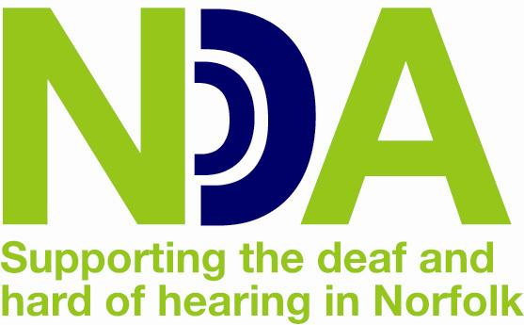

Thank you for your interest in volunteering for Norfolk Deaf Association (NDA). Please take some time to fill in the form below; this will help us to place you in the right Volunteer Role. Unfortunately, we cannot accept incomplete application forms, so if you have any difficulties filling in this form please call the NDA on 01603 404440 for assistance.
Name:

Address:

Phone Home:
Work: Mobile:
Email:

Date of birth:

How would you prefer for us to contact you?
Phone □ Email □ Letter □
What are you interested in?

Is there a particular volunteer role that you are attracted to?

- Home visiting volunteer □

- Community-based clinic volunteer □

- Assistive Listening Device Clinic volunteer □

- Mobile clinic volunteer □

- Befriending service □

- Office admin □

- Other □ ……………………………………………… (please specify)

When are you available to volunteer?

Daytimes □ Evening □ Weekends □

Please tell us any skills, qualities and experience (paid or unpaid) that you will bring to the role.

References

Please provide the details of two people who we can contact for references about you. We prefer that at least one of these references comes from a person with a professional background; for example, from a teacher or doctor, or a current or previous employer. For the second referee, a personal reference may be used.

Reference 1

Name:

Position:

Address:

Telephone:

Email:

Reference 2

Name:

Position:

Address:

Telephone:

Email:

Out of interest...

How did you first hear about NDA?

How did you find out about our volunteer vacancies?

Important Information
Personal data that you provide to NDA will be held in accordance with the Data Protection Act 1998. We understand the information that you provide is of a sensitive and private nature, therefore all staff and volunteers are bound by a confidentiality agreement.
I hereby confirm that the above details are correct to the best of my knowledge and I have read and understand the Important Information.
Name (please print) ____________________ Signed_______________ Date_________
Disclosure and Barring Service (DBS)
Please be aware that we require all our volunteers to undergo a DBS check. This is because in the course of volunteering, volunteers may work with vulnerable adults and/or young people. Having a criminal record will not necessarily stop you from volunteering with NDA. For more information or if you are worried about DBS checking, please call or email the NDA staff.
What next?

Please return this form by post to Pam Spicer (private and confidential)
Norfolk Deaf Association,
14 Meridian Way,
Meridian Business Park
Norwich NR7 0TA

or by email to
hearingsupport@norfolkdeaf.org.uk
If your form is successful, we will invite you for a face-to-face meeting.

