Norfolk Deaf Association  Friends of NDA Application Form | 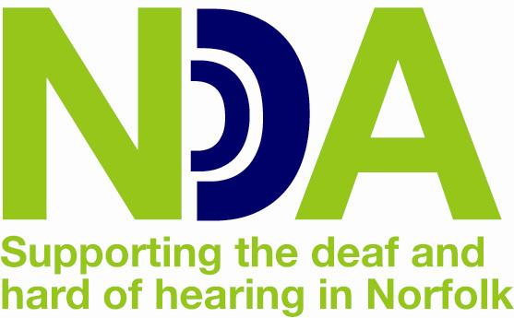

Title ...............Forename …...................................Surname..............................................................

Address ...............................................................................................................................................

.................................................................................. Postcode...........................................................

Email…………………………………………………………………………………………………………….

I/we would like to join the Friends of the Norfolk Deaf Association (tick subscription level required)
Annual Individual Subscription £15 |  | Annual Corporate Subscription £100
Annual Joint Subscription £28 |  | Corporate Life Subscription £750
Life Subscription £200

I/we enclose a cheque made payable to Norfolk Deaf Association
I/we wish to pay by Standing Order (please complete the form below)
I/we wish to give £________Weekly / Monthly / Annually to the Norfolk Deaf Association (delete as appropriate)

Boost your donation by 25p of gift aid for every £1 you donate. Gift aid is reclaimed by the charity from the tax you pay for the current tax year. (Your address will identify you as a current UK taxpayer).

I want to gift aid my donation above & any other donations I make in the future or have made in the last 4 years to Norfolk Deaf Association. I am a UK taxpayer & understand that if I pay less income tax and/or capital gains tax than the amount of Gift Aid claimed on all my donations in that tax year it is my responsibility to pay any difference. (In order to Gift Aid your donation you must tick the box).
Please notify the charity if you:
- Want to change this declaration
- Change your name or home address
- No longer pay sufficient tax on your income and/or capital gains
If you pay income tax at the higher or additional rate and want to receive the additional tax relief due to you, you must include all your gift aid donations on your self-assessment tax return or ask HM Revenue & Customs to adjust your tax code.

Signature …................................................................................ Date:…………………
……………………………………………………………..........
STANDING ORDER
If you would like to become a Friend of NDA or make a donation by Standing Order, please complete this form and send it to Norfolk Deaf Association, 14 Meridian Way, Meridian Business Park, Norwich, NR7 0TA.
Instructions to your Bank/Building Society, please pay Norfolk Deaf Association the sum of
£___________weekly/monthly/annually (delete as appropriate) from the following date………………

Your Bank/Building Society: | Branch Address:
Name(s) of Account Holder: | Signature:
Bank/Building Society Account No | Date:
Branch Sort Code: | NDA Ref: Santander UK Plc  Account no: 25138828  Sort Code 09-01-28

